Use of Dinitrosalicylic Acid Reagent for Determination of Reducing Sugar
ANALYTICAL CHEMISTRY, VOL. 31, NO. 3, p.426-428, MARCH 1959
GAIL LORENZ MILLER
Pioneering Research Division, Ouartermaster Research and Engineering Center, Natick, Mass.
Rochelle salt, normally present in the dinitrosalicylic acid reagent for reducing sugar, interferes with the protective action of the sulfite, but is essential to color stability. The difficulty may be resolved either by eliminating Rochelle salt from the reagent and adding it to the mixture of reducing sugar and reagent after the color is developed, or by adding known amounts of glucose to the samples of reducing sugar to compensate for the losses sustained in the presence of the Rochelle salt.
The optimal composition of a modified dinitrosalicylic acid reagent is given. The dinitrosalicylic acid reagent developed by Sumner and coworker (11-14) for the determination of reducing sugar, is composed of dinitrosalicylic acid, Rochelle salt, phenol, sodium bisulfite , and sodium hydroxide.
According to the authors of the test,
Rochelle salt is introduced to prevent the reagent from the dissolving oxygen (12);
phenol, to increase the amount of color produced and to balance the effect of phenol encountered in urine (13);
bisulfite, to stabilize the color obtained in the presence of the phenol (13).
The alkali is required for the reducing action of glucose on dinitrosalicylic acid.
The major defect in the test is the loss of part of the reducing sugar being analyzed. This was pointed out by Sumner (12,14), was referred by Brodersen and Rickets (2), and has been observed repeatedly in this laboratory (6,8,9). Evidence of loss of sugar is also given by the data of Hostettler, Borel, and Deuel (4) and of Bell, Manners, and Palmer (1).
As this defect appears never to have been fully remedied, the present study was carried out to investigate the different factors that might cause it. In course of investigation, the effects of varying the concentrations of the different components of the. reagent also were determined. The findings which resulted have led to the development of a modified reagent and procedure.

METHOD
The color tests were made with 3-mL aliquots of reagent added to 3-ml aliquots of glucose solution in 14-rnm tubes. The mixtures were heated for 5 minutes in a boiling water bath then cooled under running tap water, adjusted to ambient temperature.
Cooling to ambient temperature was made necessary by the effect of temperature on the absorbance of the colored reaction product (2), an effect confirmed by the present studies. The color intensities were measured in a Beckman Model DU spectrophotometer at 575 mµ with a slit width of 0.06 mm.
The reagent of Sumner and Sisler (14) and a modified reagent were used in the tests. The former contained_ approximately 0.63% dinitrosalicylic acid, 18.2% Rochelle salts, 0.5% phenol, 0.5% sodium bisulfite, and 2.14% sodium hydroxide. The modified reagent contained 1% dinitrosalicylic acid, 0.2% phenol, 0.05% sodium sulfite, and 1% sodium hydroxide.
For certain tests the modified reagent included varying concentrations of Rochelle salt. The composition chosen for the modified reagent was based on the results of preliminary tests which indicated that such a reagent was optimal and would serve best as the basis of reference for testing effects of variation in composition.
In the absence of Rochelle salt, the color obtained with the modified reagent was unstable. To stabilize the color under these conditions, 1 ml. of a 40% solution of the salt was added to the mixture of reactants subsequent to the development of the color and prior to cooling.
The modified reagent was prepared by placing all solid components in a container and dissolving them simultaneously by stirring with the required volume of sodium hydroxide solution. This was much simpler than other procedures (2, 14).
The modified reagent produced the same color with glucose from day to day, thus proving more stable in this respect then the reagent of Brodersen and Ricketts (2). Modified reagent to which Rochelle salt was added also did not change from day to day in this respect.
Depending upon storage conditions, however, the modified reagent tended eventually to deteriorate from atmospheric oxidation of the sulfite present. Deteriorated reagent was rejuvenated by the addition of fresh sulfite.
The danger attendant upon oxidation of sulfite could be avoided by preparing the reagent in large batches without sulfite, the sulfite being added to aliquots just prior to the time when the reagent was to be used.

STUDY OF VARIABLES
Removal of Dissolved Oxygen with a stream of Nitrogen. Sumner and Sister (14) indicated that the loss of glucose with the dinitrosalicylic acid was due to destruction by oxidation and based their statement on unreported results of experiments in which a stream of nitrogen was passed through the reactants. An attempt to confirm this observation in the present work indicated that passing a stream of nitrogen through a mixture of Sumner's reagent and glucose for 2 minutes prior to development of color largely eliminated the destruction of glucose (Figure 1, a).
With Sulfite. As sulfite had previously been used successfully for removing dissolved oxygen from aqueous solutions (5), it was surprising that the sulfite present in Sumner and Sisler's reagent failed to accomplish this purpose. To test whether this failure of the sulfite may have been due to interference by other components of the reagent, sulfite at a level of 0.1% was added to glucose sample's prior to mixing them with the reagent. This procedure reduced the destruction of glucose by about 70%. The results, shown in Figure I, b, thus provided strong evidence for the suspected interference by the other components of the reagent under the usual conditions of the test.
interference of rochelle salt. Comparative tests were next carried out with the modified dinitrosalicylic acid reagent to which varying amounts of Rochelle salt were added. The results, shown in Figure 1, c, clearly implicated Rochelle salt as the major factor involved in the interference with the removal of oxygen by sulfite, because, in the absence of the salt, the sulfite appeared able to remove the dissolved oxygen and thereby to protect the glucose. Aside from contributing to the loss of a portion of the glucose, the Rochelle salt caused an enhancement of the color due to the remaining glucose.
Sulfite Concentration. The effect of different concentrations of sulfite in the modified reagent (Figure 1; d) indicated that a maximum color intensity was obtained at 0.05% sulfite. In experiments not shown, essentially the same results were obtained at 0.025 and 0.1% sulfite as at the 0.05% level. Low concentrations caused a lack of linearity, while both high and low concentrations caused a depression in color intensity and a loss of glucose.
Sodium Hydroxide Concentration. The effect of different concentrations of sodium hydroxide is shown in Figure 1, e. High concentrations of sodium hydroxide led to enhanced color development, but at the same time contributed to a loss of glucose. The level of 1% sodium hydroxide appeared to be tlie most suitable, as it produced the maximum color intensity possible without concomitant loss of glucose.
Phenol Concentration. Maximum color development was approached at a concentration of about 0.2% phenol (Figure 1, f). In experiments not shown in the figure, the same results were obtained with 0.5% phenol as at the 0.2% level. Low concentrations resulted in a lack of linearity. The intensity obtained in the presence of 0.2% phenol was about 5 times that obtained in the absence of phenol. Over the range tested, the phenol had no effect on the loss of glucose.
Dinitrosalicylic Acid Concentration. When the amounts of dinitrosalicylic acid were varied, the color intensity approached a maximum at a concentration of 1% (Figure 1, g). The dinitrosalicylic acid, like the phenol, had no effect on the loss of glucose over the range tested.
Other Substances. The results of the preceding tests suggested the possibility that other substances might affect the dinitrosalicylic acid test. For example, it was of interest to ascertain whether, in using the test for the measurement of cellulase activity (8, 10), the presence of Carboxymethylcellulose and citrate buffer at pH 5 might cause, interference. With amounts of Carboxymethylcellulose and citrate buffer corresponding to those used in the cellulase measurement, the effects shown in Figure 1, h, were produced. The Carboxymethylcellulose caused an enhancement in color, whereas the citrate caused a depression. A mixture of the substances approximately neutralized the two opposite effects. To determine whether the effect of the citrate may have been a consequence of its buffering action, tests were made with acetate buffer of pH 5 at an equivalent concentration. The acetate did not, however, affect the test.

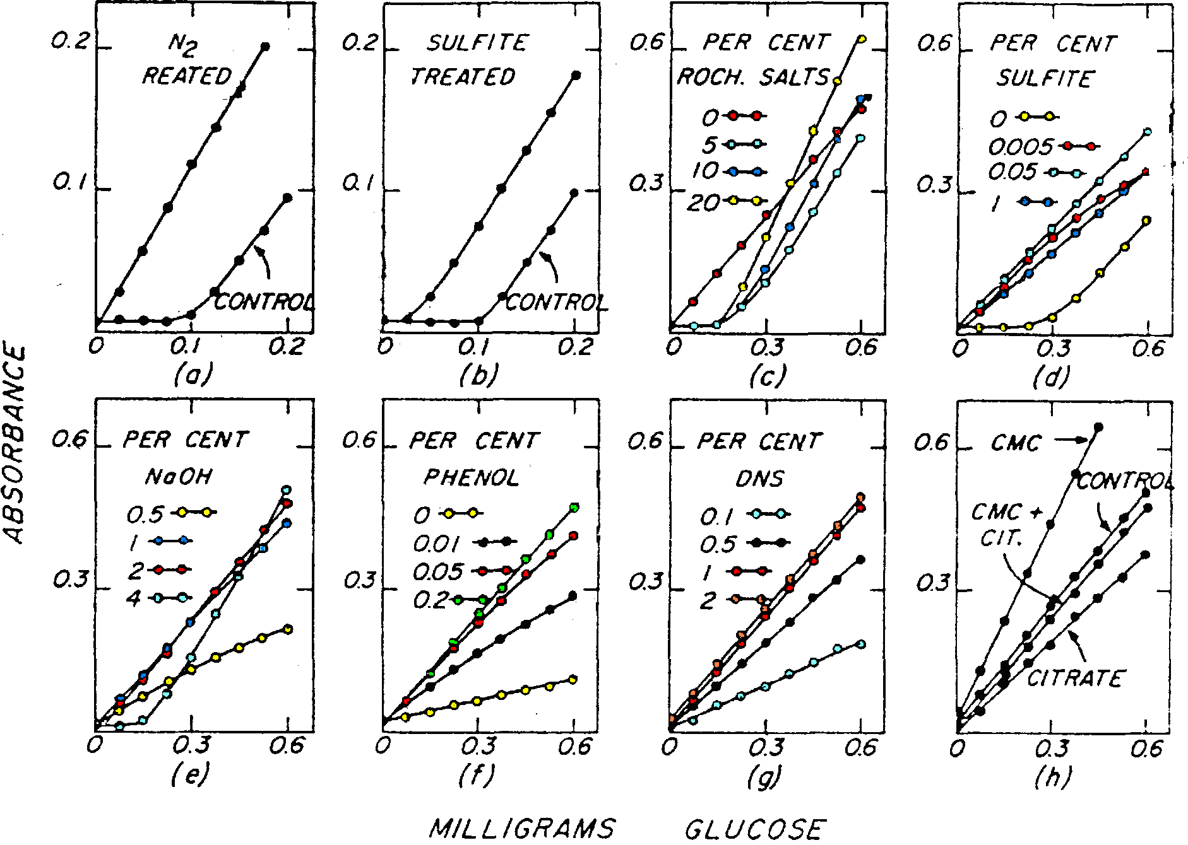
Figure 1. Effect of variables on color produced with glucose and dinitrosalicylic acid reagent
- Stream of nitrogen passed through mixture; Sumner's reagent
- Sodium sulfite treatment prior to addition of Sumner's reagent
- Rochelle salt concentration; modified reagent
- Sulfite concentration; modified reagent
- Sodium hydroxide concentration; modified reagent
- Phenol concentration; modified reagent
- Dinitrosalicylic acid concentration; modified reagent
- Carboxymethylcellulose, citrate, and mixtures of both present; modified reagent
FINAL METHOD
When pure reducing sugar solutions are involved or when any contaminants which may be present are known not to affect the color development or to cause any loss of reducing sugar, the modified reagent in the absence of Rochelle salt is used. For stabilization of the color produced under such conditions, Rochelle salt is added to the mixture immediately after the development of the color and before the mixture is cooled. The time of heating is increased to 15 minutes because the 5 minute period, adequate for the original procedure, does not produce complete color development in the modified procedure. By this method linearity of data, protection of glucose, and stability of color are realized.
If interfering substances occur in unknown samples, special controls are run. Such controls consist of standard reducing sugar solutions to which appropriate amounts of the interfering substances are added. When the interfering substances bring about a loss of reducing sugar, and particularly when the amounts of reducing sugar to be measured in unknown samples are equal to or smaller than the amount lost, known amounts of glucose are added to both the unknown samples and the standards.
The procedure of adding glucose can also be applied advantageously to compensate for the loss of reducing sugar incurred when Rochelle salt is incorporated in the dinitrosalicylic acid reagent. For example, it is convenient in the cellulase test (10) to introduce glucose into the carboxymethyl-cellulose-citrate substrate and to use modified dinitrosalicylic acid reagent containing 20% Rochelle salt (8). Under these conditions the separate addition of Rochelle salt to the reaction mixture after color development is omitted. The controls for such tests consist of a blank and standard glucose solutions, each containing Carboxymethylcellulose, citrate, and compensatory glucose.
DISCUSSION
The chemistry of the dinitrosalicylic acid test for reducing sugar has been clarified previously, at least in part. The 3,5-dinitrosalicylic acid is reduced to 3-amino-5-nitrosalicylic acid while, in the simplest instances, the aldehyde groups appear to be oxidized to carboxyl groups (4). The facts, however, that the equivalence between amino nitrosalicylic acid produced and sugar is not exact (4) and that different sugars yield different amounts of color (1, 4, 7), suggest that the chemistry of the test-may actually be appreciably more complicated.
Such complications could conceivably be associated with the various decomposition reactions of sugars in alkaline solution (5). If this explanation is correct, the reaction of the sugar aldehyde grouping with dinitrosalicylic acid could be viewed as competing with side reactions involving decomposition of the sugar. The effects of different concentrations of the various constituents of the dinitrosalicylic acid reagent, and also of extraneous substances such as Carboxymethylcellulose or citrate buffer, upon the amount of color produced and upon the destruction of glucose, as shown in the present study, could similarly be interpreted as effects upon the nature and degree of side reactions.
The dinitrosalicylic acid reagent, in a form consisting only of dinitrosalicylic acid dissolved in strong alkali, has been used with apparent success for molecular weight measurement of starch breakdown products (7). This method depends upon the assumption that all higher oligosaccharides of the homologous series starting with maltose would produce equivalent amounts of color -with the reagent. Actual studies of the reactions of members of homologous series with the dinitrosalicylic acid reagent, starting with the disaccharide, have not been reported, but would be of considerable interest in the present connection.
The principal virtue of the dinitrosalicylic acid test for reducing sugar lies in its great convenience compared to most other sugar tests, particularly when large numbers of tests must be carried out. However, the factors discussed above must be given due consideration to avoid misinterpretation of results.

LITERATURE CITED

(1) Bell, D. J., Manners, D. J., Palmer, A., J. Chem. Soc. 1952, 3760.
(2) Brodersen, R., Ricketts, H. T., J. Lab. Clin. Med. 34, 1447 (1949).
(3) Gilman, H., "Organic Chemistry, Advanced Treatise," 2nd ed., Vol. 2, p. 1640, Wilev, New York, 1943.
(4) Hostettler, F., Borel, E., Deuel, H., Helv. Chzm. Acta 34, 2132 (1951).
(5) Kolthoff, I, M., Lingane, J. J., 'Tolarography,'' Interscience, New York, 1946.
(6) Mandels, G. R., Quartermaster Research and Engineering Center, Natick, Mass., private communication.
(7) Mever. K. H., van der Wvk, A. J. A.. Peng," C., Helv. Chim. Ada '37, 1619 (1954).
(8) Miller, G. L., Blum, R., Glennon W. E., Quartermaster Research and Engineering Center, Natick, Mftss., unpublished data.
(9) Reese, E. T., Quartermaster Research and Engineering Center, Naticl., Mass., private communication.
(10) Reese, E. T., Siu, R. G. H., Levinson, H. S., J. Bacterial. 59, 485 (1950).
(11) Sumner, J. B., J. Biol. Chem. 47, 5(1921).
(12) Ibid., 62, 287 (1924-25).
(13) Ibid., 65, 393 (1925).
(14) Sumner, J. B., Sisler, E. B.. Arch. Biochem.4, 333 (1944).

received for review November 4, 1957. Accepted September 23, 1958.

