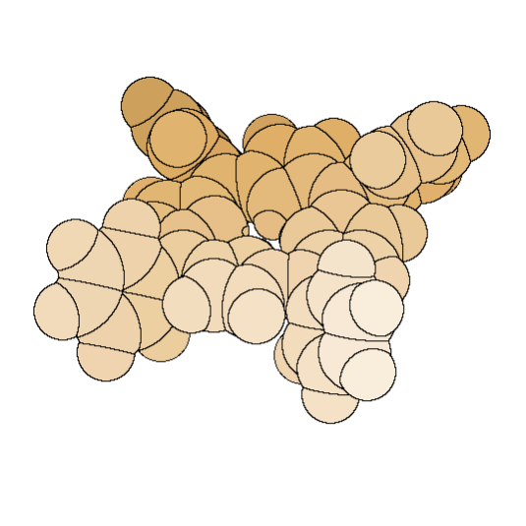


Laboratory

Bio

Inorgnic

Chemistry

Πανεπιστήμιο Κρήτης University of Crete
Τμήμα Χημείας Chemistry Department

Εργαστήριο
Βιοανόργανης Χημείας
Education, Audiovisual & Culture Executive Agency

Erasmus Intensive Program – BIMASOUTI – 2014

REGISTRATION FORM

From :  SURNAME: …………………………………….  NAME: ………………………………………….  DATE OF BIRTH: ……………………………...  ADDRESS: ……………………………………... TELEPHONE: …………………………………..  FAX: …………………………………………….. E-mail: ………………………………………….  Affiliation: ……………………………………… | To :  Erasmus Intensive Program  BIOINSPIRED MATERIALS FOR SOLAR ENERGY UTILISATION  7 – 18 July 2014
I certify that I have read and understood all terms of participation in the BIMASOUTI – 2013, Erasmus Intensive Program.

Date: …/…./2014
CERTIFICATES ENCLOSED:
1. Curriculum Vitae (CV) ◻
2. Two recommendation letters ◻
2. Other certificates (ex. Lower degree) ◻

Signature

